Blackbird Leys Parish Council

Strategic Plan 2024-5

# Contents

## Part 1: The Leys & the Blackbird Leys Parish Council

1. Blackbird and Greater Leys
2. Parish people
3. Parish map
4. Committees and working groups
5. Communication and Engagement

## Part 2: Strategic Plan

1. Introduction
2. Our vision
3. Our commitment
4. Our priorities and objectives
5. Review and update

## Blackbird and Greater Leys

[a bit on history and demographics] [Highlights from the community profile]

Since 1990 Blackbird Leys Parish Council has been representing the interests of people in Blackbird and Greater Leys. It is not a church parish, but the first of 3 tiers of local government. It is one of the largest civil parishes in Oxfordshire, working with the Oxford City Council and the Oxfordshire County Council to support the 13,500 residents here. We are consulted on things like planning, transport, recycling, recreation, nature and the environment, education and health services and crime prevention. It also makes grants to support local community projects and runs or publicises events.

At present the Council is involved in:

* Monitoring the redevelopment project and its impact on residents and wildlife.
* Creating a neighbourhood plan.
* Providing information for residents on local issues and services.
* [possibly something on cost of living crisis and on community transport?]

# Parish councillors and officers

[take data from https://www.blackbirdleysparishcouncil.gov.uk/councillors and https://www.blackbirdleysparishcouncil.gov.uk/contact-us]

There is one part-time clerk and 10 councillors plus 4 vacancies. Elections are held every 4 years, with the next one scheduled for May 2026.

Blackbird Leys Parish Council meetings are held at 7 p.m. on the last Tuesday of the month in the Blackbird Leys Bowls Club. They are open the public.

# Parish map

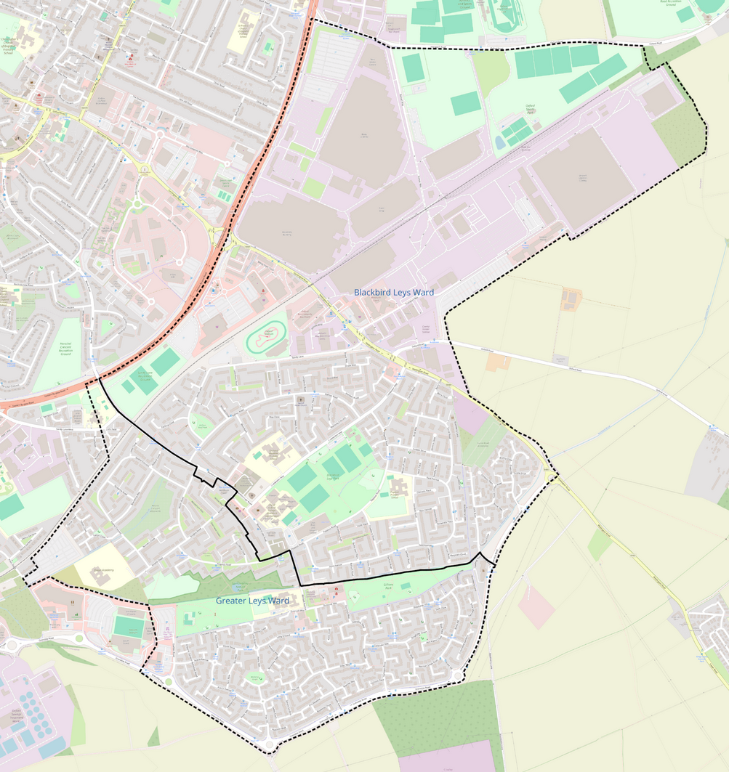

# Committees and working groups

## Planning Committee

This committee responds to planning applications and is consulted on local plans like the Blackbird Leys redevelopment. It will be leading the development of a Neighbourhood Plan. Its meetings are on the third Tuesday of each month and are open to the public.

# Events Committee

This committee plans events to be run by or in collaboration with the parish council, applies for grants, and publicises events in the Leys and engages with the community on behalf of the parish council.

## Staffing Committee

This committee interviews applicants, appraises appointed staff and manages disciplinary procedures.

## Strategic Aims Working Group

This is a working group that can include councillors and local volunteers. Its task is to develop a strategy for the parish council (what we will be doing each year), monitor its progress and revise our plans to take account of opportunities and difficulties.

## Representatives

Some parish councillors take on the role of representing the council on other bodies or around the estate. This is primarily an information gathering task, attending meetings organised by the city and county council and other bodies, asking questions to find out what is happening or planed which impacts Blackbird and Greater Leys, then reporting back to the parish council. Each representative tries to keep up to date in a specific topic, such as transport, planning, climate change and the environment, community safety, health and well-being.

# Communication and engagement

As a Parish Council, we work on your behalf – we want to know what issues your may have or what projects you may be working on so that we can champion your efforts and support where we can. We want to continuously engage with residents to learn from them.

We also want you to know what the Council is doing so that you can guide our plans, decisions and actions. We will be ramping up our community engagement as we start working on developing a neighbourhood plan. We want to know what kind of place you want the Leys to become in the next few years. What should be protected and where should improvements go?

Here are the ways to stay in touch with the Parish Council:

* Check our web site: https://blackbirdleysparishcouncil.gov.uk/ .
* Facebook page (https://www.facebook.com/Clerk2thecouncil) and groups (Blackbird Leys Community Group, https://www.facebook.com/groups/656236718050193).
* Direct email – you are welcome to email the Parish Council clerk directly.

# Strategic Plan

# Introduction

[modify from Eynsham Parish Council, with its clear explanations. Update with our process dates.]

Over the last two years, our Strategic Aims Working Group has been looking at how we could help develop Blackbird and Greater Leys – the place and the community. In addition to representing residents, what could we do to make the Leys better?

# Our vision

[this needs more than just X is a great place to belong. It needs to highlight the future – an improved neighbourhood and an active community able to thrive, yet also able to overcome challenges in the future through its resilience]

Blackbird and Greater Leys is a great community that has survived great challenges. Lets work together to make it stronger and able to take control.

# Commitment as councillors

[this needs more than what Eynsham has written. Say again what the parish council can and cannot do and how parish councillors can help. Or leave out this section.]

Councillors serve the community. We commit to not just take up individual issues, but to work with residents to develop the Leys in ways that make our lives better. In particular we want to help:

1. Encourage and support community development in the Leys, creating more active self-directed teams and organisations dedicated to improving particular aspects of life here.
2. Develop the place, by making a neighbourhood plan, protecting what residents need and like and guiding infrastructure improvements.

# Priorities and Objectives

[need to simplify the stuff we have already written, concentrating on what we will do in the next 12 months]

## A more visible parish council

We want to make more residents aware of what the council does, can and cannot do, and how we can help. Steps to achieve this include:

1. Commission a new web site with new branding, and employ an editor to update local news.
2. Produce occasional community information posters, leaflets, maps and newsletters.
3. Organise well publicised events.
4. Promote the Leys and the Parish Council through press, networking, social media and advertising.

## Learning about the Leys

A key aim is for the parish council to learn more about the Leys, both the place and the community. It is with a more detailed knowledge that we can better serve people. We will:

1. We will build up a knowledge base about Blackbird and Greater Leys, collated from documents and the work of our parish council representatives.
2. Spend time listening to residents outside the formal parish council meetings.
3. Find out more about community needs through meetings with local groups and other stakeholders, complemented by small scale surveys.
4. Learn what residents value about local places through community mapping events.
5. Present what we have learned to residents through maps and a directory of community activities on our web site and in events.

## Improving the neighbourhood

As a parish council we have powers to do a number of things. They include:

1. Investing in improving community assets using the Community Infrastructure Levies (CIL) received from developers in Blackbird and Greater Leys.
2. Developing a neighbourhood plan, which, once approved, will set local conditions for future planning applications in the Leys.

The Parish council will:

1. Identify ways we can invest funds from CIL to improve the Leys.
2. Set up a group to develop a neighbourhood plan.

## Community Engagement and Development

Community development is a process where people come together to take action on what's important to them. The parish council is a public agency. Through community engagement it can facilitate community development to make the Leys a better place to live.

The parish council and its councillors will go beyond the formal parish council meetings to:

1. Meet more often with community groups.
2. Arrange more opportunities for residents to meet parish councillors.
3. Join in productive online discussions to find ways to make things better.
4. Take part in community meetings and events (both organised by the parish council and by others).
5. Conduct online or paper surveys of residents.
6. Set up working groups with parish councillor and residents as members.

Once we understand each other better, there are several ways the parish council could help, including:

1. Producing a guide to how to set up a community group and get funding.
2. Promote funding and partnership opportunities.
3. Giving small grants to get groups started.
4. Publicising the work of community groups inside and outside the area.

# Review and updates

[invite people to working group to review and update plans. Include links to documents with more details]

Our plans will be reviewed and adjusted annually. There will be a report on progress at each full council meeting. In addition, there will be open day events twice a year.